
LRA is pleased to be able to tell you that the Expressway ~ westbound closure of Birchwood Way between Blackbrook Avenue and College Place (which has been in place since August to enable the initial stage of the Warrington East Phase 2 project to get underway) ~ is due to re-open in the early hours of Monday 26th November ….. 3 weeks earlier than planned.

Detailed plans for the Warrington East Project are illustrated below.

Hopefully this will relieve the dreadful congestion we have been having to tolerate ~ especially down Harpers Road ~ since the roadworks began.



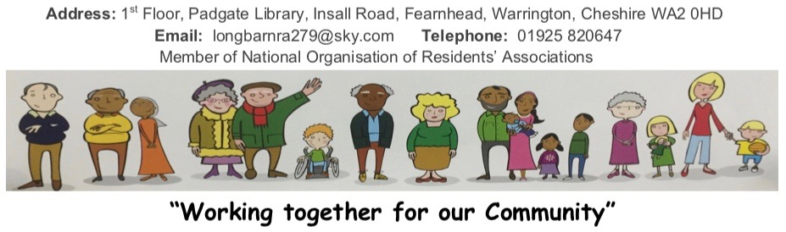
COLLEGE PLACE ROUNDABOUT

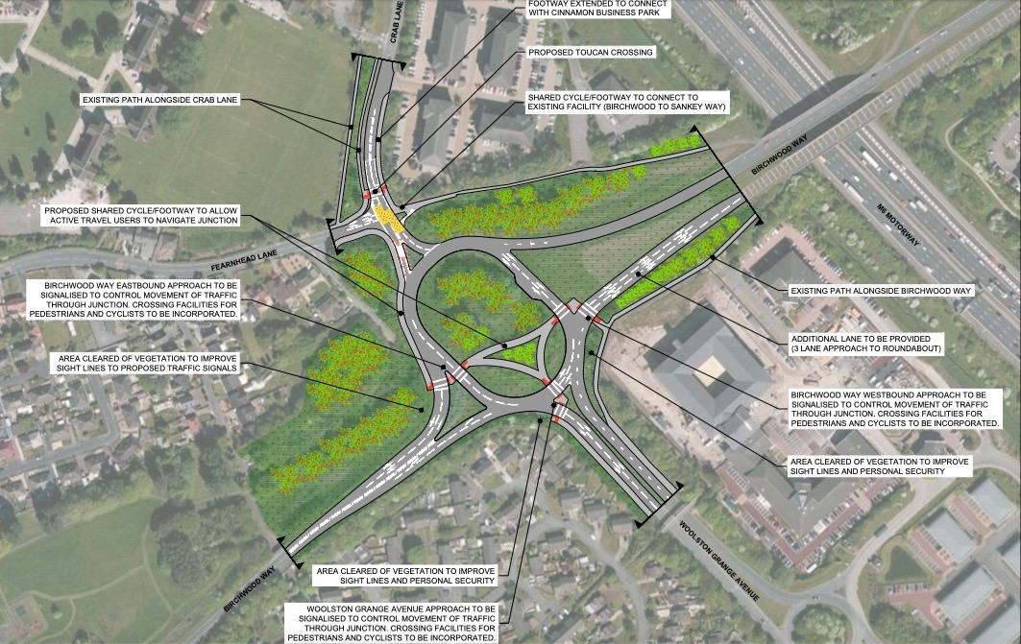
BLACKBROOK AVENUE / BIRCHWOOD WAY ROUNDABOUT

