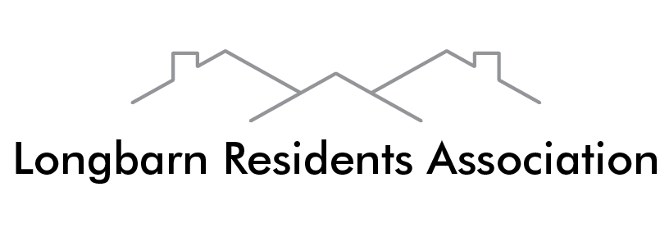

Representing Anderson Close, Blackburne Close, Burnet Close, Carpenter Grove, Church View, Duckworth Grove, Fallowfield Grove, Freshfields Drive, Guildford Close, Lovage Close, Mayberry Grove, Mullion Grove, Oxmead Close, Pasture Lane, Peasley Close, Saffron Close, Sage Close, Sorrell Close, Station Road South and West View.

Freshfields Drive, Saffron Close, Lovage Close and Carpenter Grove.

Minutes of the Committee Meeting held on

Thursday 29th October 2015 at 7.30 pm in Padgate Village Club.

Present (15): Raj Asani, Lynn Colter-Howard (Vice-Chair), Rosa Dale, Howard Klein, Chris Merritt, Dermott Lappin (Treasurer), Linda Lappin, Pat Longshaw, Geoff Orange (Chair), Wendy Orange, David Pearson, Richard Robinson, Ann Sudlow, Gary Wells (Comms. Offr.), Gareth Thomas

(Note: Items 4 and 5 below were taken last)

- Apologies: Vicki Collier

- Minutes of Last meeting on website – no changes

- Matters arising/Correspondence - None

- Reply from WBC (Stephen Broomhead) to LRA’s letter

  - Birchwood Way – Prof Broomhead is now saying there is only funding for one section (unlike last November when we were told the whole length would be dualled within 2 or 3 years).

Geoff led a discussion on how to get more funding for dualling. Howard said we should bypass WBC and approach the Local Enterprise Panel (LEP) directly, since all funding goes through them. Even the current construction (Moss Gate to M62) is being funded by LEP.

  - Harpers Road

Prof. Broomhead’s reply showed that he still did not realise that the Harpers Road Traffic Study contained serious errors and was never corrected. This will be pointed out to him in LRA’s reply.

  - Speeding on the Expressway / Woolston Grange Avenue, and (iv) Parking

Prof Broomhead’s replies were discussed briefly.

Rosa has seen NCA staff parking in Blackburne residents’ personal parking spaces. Gareth reported a serious accident last weekend where a speeding car on WGA mounted the roundabout and turned upside down.

- Road Safety – Blackburne / Anderson – as in Item 6 below

- Road safety – “Pink Bridge” path

GO expressed severe dissatisfaction with the attitude of WBC / the Mayor, who has said that “the petition isn’t going anywhere”. What is the point of a petition if it is ignored? GO is still trying to find out what exactly the WBC / Mayor are planning to do to fix the problem. The wooden fence panels recently installed are inadequate.

- Base for LRA

Prof Broomhead’s short reply “We will continue to seek appropriate accommodation for you” doesn’t really say anything.

GO said that while PVC is a suitable place for meetings, we also need a location of our own to store our LRA equipment and to be able to call additional meetings etc.

The landlord of the Longbarn Shop has said that if we can get funding to adapt the spare section of the building, we can meet there for no change.

Dermott suggested we also explore Padgate Community Centre, which GO will do.

- Consultation by WBC

Geoff explained that the link in the letter he circulated leads to three main documents (as listed in the letter) which he asked Committee members to read carefully.

The link is:

http://www.warrington.gov.uk/info/200564/planning_policy/1903/local_plan/6

We agreed to a special meeting on Thursday November 19th at PVC especially to discuss this matter. Richard was asked to take the lead in this area.

Note: Richard has downloaded these three documents and can supply them to those interested.

It was unanimously agreed to invite all five Borough Councillors (three for Poulton North and two for Poulton South) for Longbarn to all full LRA meetings

- Road Safety – Blackburne to Anderson

Geoff consulted Diane White who put him in touch with Chris Skimkiss (WBC) who is investigating.

- The Land Trust – Hippos play Area

The application for £50K funding has been submitted to WREN. The LT says we have made a very good case. The WREN Board’s decision is due around late December. If we are successful, work will start in April 2016.

- Treasurer’s report

We have £9650 in the Lottery a/c. We also have £7479 in the Main a/c, which includes £5K received from WBC that is ring-fenced for the Hippos.

Dermott gave details of the Adult Xmas Night Out with singer Darren Shaw on Friday 11th December at PVC – tickets £4 including buffet

- Hippos Raffle

Geoff said that additional prizes are being procured. The main organisation is by Cheryl and Mark Hoddle. Geoff appealed for more sellers of raffle tickets – several Committee members took 10 or 20.

It was also agreed to sell door-to-door around Blackburne and Anderson etc, on Saturday 7th November, meeting at The Hippos at 1030 am. Richard to email membership on this.

- Padgate Station

Painting around the station and on Padgate Bridge is of very poor quality. Network Rail are unwilling to spend money ahead of the re-franchising next March. Geoff says a “Friends of Padgate Station” is needed – but LRA officers don’t have time to include this within LRA activities. Perhaps LRA members living neat the station (Station Road South etc) could set one up.

- Quiz Night – Friday 20th November

This is going ahead to maintain the momentum we have developed in the popular Quiz nights.

- AOB

    - The Head of Christ Church School (Mr Ian Williams) will attend the next full meeting on 12th November – he wants to squash the rumours about housing developments on school land.
    - Geoff raised the issue of the need to deal with false rumours concerning travellers
    - Pat Longshaw raised the issue of the Nynex cables put in in 1990, and recent Virgin work. Not everyone has access. Rosa and Howard referred to the 2-metre easements on the road-side of properties .
    - Gary asked to be informed of all events, with photos if possible. Geoff asked the Chairmen of all subcommittees to pick out items for the website and inform Gary.
    - Lynn spoke of problems in a certain area of Anderson Close, on which she is working closely with Muir for a solution.

The Chair closed the meeting at 8.55 pm.

RR 30-10-15, 11-11-15

